Fari Market Analysis

Fari Product Summary
Fari is an AI eldercare companion robot designed to support clinical monitoring, emotional wellbeing, and resident safety in assisted living and care environments. The platform combines edge AI processing on NVIDIA Jetson Orin NX hardware with a 14-sensor suite and a governance framework called the Supervised Ethical Override Module (SEOM), which is intended to ensure that all recommendations remain advisory and under user authority.

The United States is experiencing a rapid demographic shift toward an older population, creating growing demand for technologies that support independent living, safety monitoring, and emotional wellbeing among older adults. Fari, an AI-powered eldercare companion robot developed by InGen Dynamics, is positioned at the intersection of companion robotics, remote monitoring, and assisted-living support technologies.

This analysis estimates the addressable market for Fari using both top-down and bottom-up methodologies based on publicly available demographic, labor, and technology adoption data. The analysis finds a reconciled Total Addressable Market (TAM) of approximately 12.3 million potential users in the United States and a Serviceable Available Market (SAM) of approximately 5.2 million seniors when focusing on individuals living alone.

The findings suggest that increasing caregiver shortages, rising labor costs, and growing acceptance of AI-enabled technologies among older adults create favorable market conditions for eldercare companion robotics. Fari’s combination of emotional companionship, safety monitoring, and clinical-support capabilities positions it to address multiple unmet needs within the aging population.

Market Background
Population aging is one of the most significant demographic trends affecting healthcare and social services in the United States. According to the U.S. Census Bureau, approximately 61.2 million Americans were age 65 or older in 2024. This population is expected to continue growing over the coming decades due to increased life expectancy and the aging of the Baby Boomer generation.

Simultaneously, healthcare institution face increasing pressure from labor shortages among home-health and personal-care workers. These shortages create opportunities for technology-enabled solutions that can supplement human caregivers while helping older adults maintain independence and quality of life.

Companion robotics has emerged as one such solution. Modern companion robots extend beyond social interaction and increasingly incorporate health monitoring, fall detection, medication reminders, emergency notifications, and communication support. Fari represents this next generation of eldercare technology by combining AI-driven companionship with monitoring and safety functions.

Raw Data
Focusing on data in the United States, and defining elder as anyone age 65 or above. There is an estimated total of 61,245,283 seniors in US as of 2024 according to US Census. Out of that, 97% of seniors live in households and 42% of that population live alone. Shifting the focus to technology, AI and electronic adoption rate of seniors, according to various statistics provided by Pew, smartphone dependency for age 65 and above is 17%, while smartphone ownership for age 65 and above is 78%. AI adoption interest average for population age 50 and above is 38.83% in 2025. According to OECD, old-age dependency ratio on average globally is 35.2, while statistics isn’t available for US, that’s 35.2% of elders globally who need assistance in daily life. Moving on to employment statistics, according to Bureau of Labor Statistics, median wage of Home Health and Personal Care Aides per year is $34,900 as of 2024, Home Health and Personal Care Aides employment is 4,347,700 jobs, Home Health and Personal Care Aides employment change between 2024-34 is 739,800 more jobs.

Key Market Drivers
1. Aging Population Growth
The primary driver of demand for eldercare robotics is the expanding senior population. The United States currently has more than 61 million residents over age 65, creating a large potential customer base for technologies that support aging in place. In addition to population growth, older adults increasingly prefer to remain in their homes rather than relocate to institutional care settings. This trend creates demand for technologies capable of extending independent living.

2. Caregiver Labor Shortages
The Bureau of Labor Statistics reports approximately 4.35 million Home Health and Personal Care Aides employed in the United States. Despite this large workforce, labor shortages remain significant. The BLS projects approximately 739,800 additional positions will be needed between 2024 and 2034, making home-health aide one of the fastest-growing occupations in the country.
These shortages increase the attractiveness of technology solutions that can automate routine monitoring, facilitate communication, and support caregivers.

3. Rising Care Costs
The median annual wage for Home Health and Personal Care Aides is approximately $34,900. Although wages remain relatively modest, the overall economic burden of eldercare continues to increase due to workforce shortages and growing demand. AI-assisted monitoring systems may help reduce caregiver workload and improve efficiency without replacing human care.
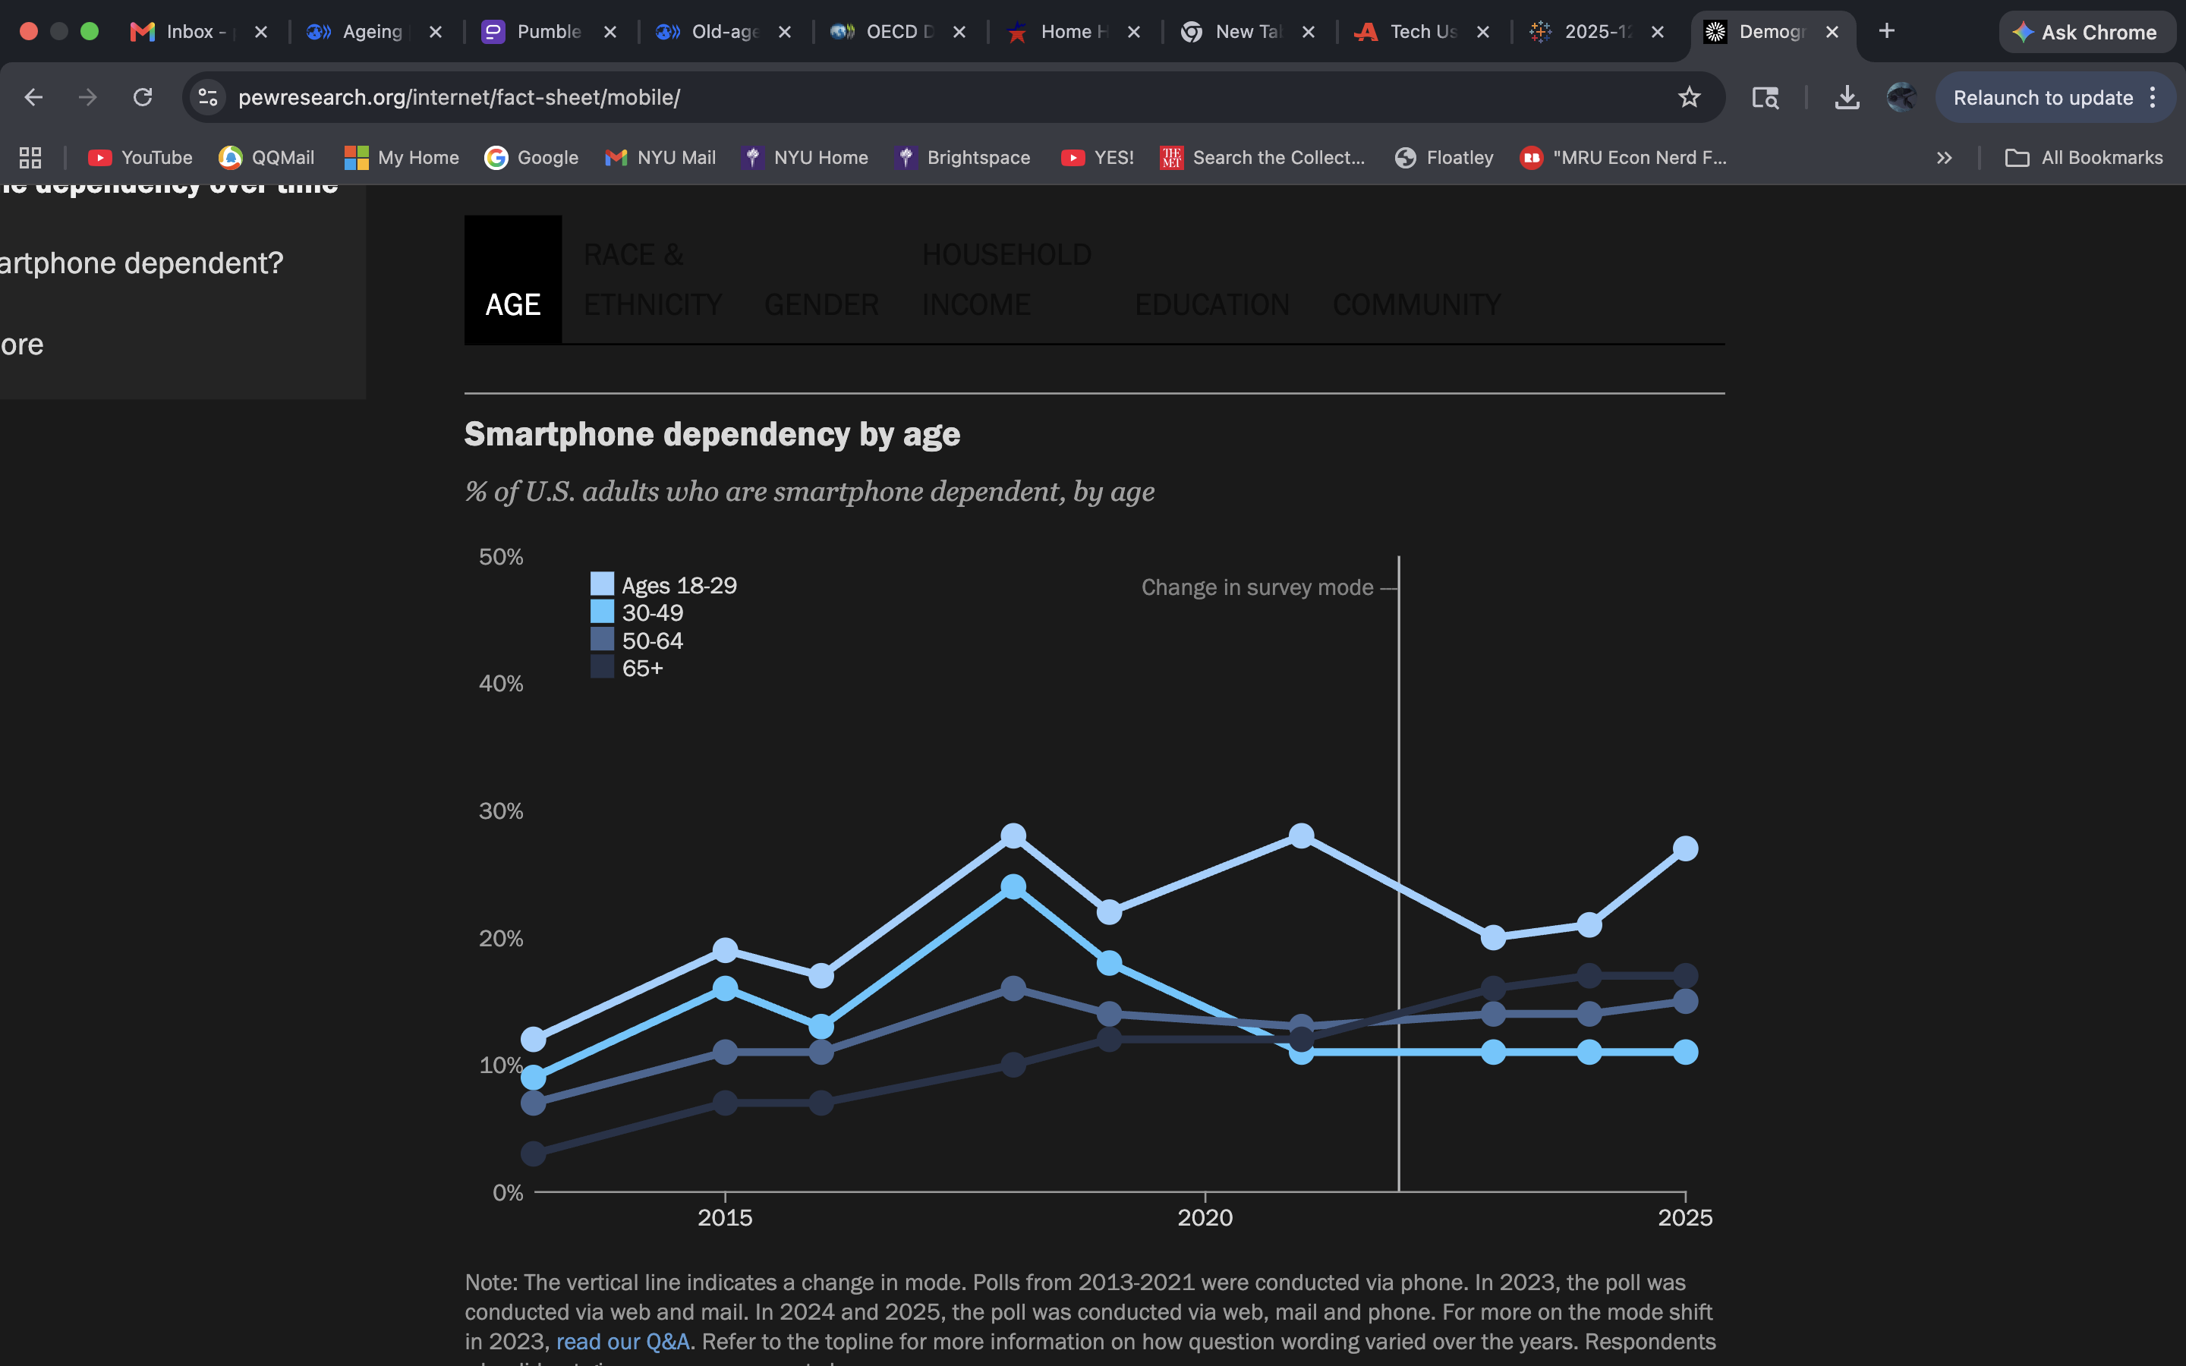
4. Technology Adoption Among Older Adults
Technology adoption and dependency among seniors has increased significantly during the past decade.
Recent survey data indicate:
- Approximately 78% of adults age 65+ own smartphones.
- Approximately 38.8% of adults age 50+ express interest in AI-enabled technologies.
These findings suggest that barriers to technology adoption among seniors are lower than in previous generations and that a substantial portion of the population may be willing to engage with AI-powered companion systems.

Top-Down Market Sizing
A top-down market sizing approach begins with the total senior population and applies adoption filters.
Step 1: U.S. Population Age 65+
61,245,283 individuals
Step 2: Seniors Living in Households
Approximately 97% of seniors live in households rather than institutional settings.
61.2 million × 97%
= 59.4 million
Step 3: Technology Readiness
78% smartphone ownership among adults age 65+.
59.4 million × 78%
= 46.3 million
Step 4: AI Adoption Interest
38.8% AI willingness among adults age 50+.
46.3 million × 38.8%
= 17.98 million

Top-Down TAM Result
The top-down methodology estimates approximately 18.0 million potential users for eldercare companion robotics in the United States. Sensitivity analysis produces a range of approximately 9.3 million to 23.2 million users.

Bottom-Up Market Sizing
The bottom-up approach estimates market demand using caregiver workforce constraints.
Step 1: Home Health and Personal Care Aides
4,347,700 workers
Step 2: Seniors Supported per Aide
Assumption: each aide supports approximately five seniors.
4.35 million × 5
= 21.7 million
Step 3: Technology Readiness
21.7 million × 78%
= 16.95 million
Step 4: AI Adoption Interest
16.95 million × 38.8%
= 6.58 million

Bottom-Up TAM Result
The bottom-up methodology estimates approximately 6.6 million potential users.
Sensitivity testing across 1–10 seniors per aide generates a range from approximately 1.3 million to 13.2 million users.

Reconciled Market Estimate
Market sizing methodologies often produce different results because they measure demand from different perspectives. The top-down approach captures the entire population potentially interested in eldercare technology, while the bottom-up approach reflects practical caregiving constraints. To balance these perspectives, the analysis averages the two estimates:
Top-Down TAM: 17.98 million
Bottom-Up TAM: 6.58 million
Reconciled TAM:
(17.98 + 6.58) ÷ 2
= 12.28 million potential users
This reconciled estimate serves as the primary TAM for the rest of the analysis.

Serviceable Available Market (SAM)
While many seniors could theoretically benefit from companion robotics, not all represent realistic customers.
A narrower segment consists of seniors who live alone and therefore may benefit most from companionship, safety monitoring, and remote support.
Research suggests approximately 42% of seniors live alone.
12.28 million × 42%
= 5.16 million

SAM Estimate
The serviceable available market for Fari is estimated at approximately 5.2 million seniors.
This group represents the most immediately addressable customer segment for companion and monitoring technologies.

Competitor Profiles
ElliQ from Intuition Robotics
Product description
ElliQ is an AI-powered companion robot designed to support independent aging among elders. The platform combines conversational AI, wellness coaching, social engagement tools, and entertainment features to reduce loneliness and encourage healthy behaviors. Companion robot is highly effective at reducing loneliness, increasing social connection, and improving wellness metrics among older adults

Key capabilities include:
- Medication reminders
- Health and pain tracking
- Exercise and wellness recommendations
- Family communication tools
- Photo and message sharing
- Community activities such as virtual tours and bingo
- Music, news, stories, and games
- Conversational companionship

Pricing
- One time fee of $249
- Annual membership of $588
- $936 membership for 24 months
- $59/month if paying monthly

Distribution channel
- Purchase directly from their website.

Catalia Health Mabu
Product description
Mabu is an AI-powered healthcare companion robot designed to support patients with chronic illnesses through personalized conversations, medication reminders, symptom monitoring, health coaching, and treatment-adherence support. The system uses AI and behavioral psychology principles to engage patients in daily interactions while collecting health information and providing insights to healthcare providers.

Pricing
- Patients do not pay directly
- Medical entities pay for patients to use at home

Distribution channel
- Indirect distribution

Joy For All Companion Pets
Product description
Joy for All Companion Pets are interactive robotic cats, dogs and other animals designed to provide comfort, companionship, and emotional support for older adults. Using touch and motion sensors, the pets respond to petting, hugging, and interaction through realistic movements, sounds, and behaviors that mimic real animals. Life-like companion robots reduce loneliness and low moods by providing non-medical behavioral interventions for older adults.

Pricing
- $64.99-$179.99 each

Distribution channel
- Can be purchased directly on website or on Amazon

Labrador Retriever
Product description
Labrador Retriever is an assistive mobile robot designed to help older adults and individuals with mobility limitations retrieve, transport, and access household items. The robot uses autonomous navigation, obstacle avoidance sensors, and programmable routes to move throughout a home, delivering items to users and reducing the need for physical movement. Advanced models feature automatic item retrieval, adjustable-height storage decks, scheduled deliveries, and voice-control integration. It shifts away from emotional comfort or medical screening, focusing instead on improving physical independence and lowering physical strain for individuals with mobility impairments.

Pricing
- No price listed publicly

Distribution channel
- Only available to professional organizations that provide care services at home home and in group settings

Lovot
Product description
LOVOT is an AI-powered companion robot designed to foster emotional attachment, comfort, and wellbeing through social interaction. Equipped with more than 50 sensors, machine learning algorithms, touch-responsive behaviors, facial recognition, and autonomous mobility, LOVOT is designed to build emotional bonds with users and reduce feelings of loneliness through continuous interaction and companionship. It focuses on improving short-term mood, opening communication channels, and providing a sense of unconditional acceptance for vulnerable populations.

Pricing
- $2805.75-$3601.51+

Distribution channel
- Purchase on their direct web store

PARO
Product description
PARO is an interactive therapeutic robot modeled after a baby seal and designed to provide emotional support, comfort, and social engagement for older adults, particularly individuals with dementia and cognitive impairments. Equipped with tactile, light, auditory, temperature, and posture sensors, PARO responds to touch, voice, and environmental stimuli, adapting its behavior through repeated interactions with users.

Pricing
- Not publicly listed

Distribution channel
- Distributed to medical facilities
Adoption Barriers According to Research Articles
Although companion robots such as Fari have significant potential to support aging-in-place, emotional wellbeing, and caregiver capacity, widespread adoption among older adults remains constrained by several behavioral, technical, and social barriers.

A systematic review of human-robot interactions among older adults found that robot acceptance is strongly influenced by perceived usefulness, ease of use, safety, reliability, self-efficacy, emotional connection, and intention to use (https://pmc.ncbi.nlm.nih.gov/articles/PMC12167747/pdf/nihms-2034416.pdf). While many participants recognized the potential benefits of robots for independent living, companionship, reminders, and health monitoring, they often preferred human assistance for personal and emotional care activities. The review concluded that successful adoption depends not only on functionality but also on users developing trust and emotional comfort with the technology.

One major barrier is technological confidence. Older adults frequently report concerns about learning new technologies and operating complex systems. If robots are difficult to understand or require extensive training, adoption rates decline significantly. Ease of use therefore becomes a critical determinant of long-term engagement. Researchers have emphasized that robots must be designed around older adults’ capabilities, preferences, and daily routines rather than requiring users to adapt to the technology.

Trust and perceived value also influence adoption. A longitudinal study examining socially assistive robots found that older adults who perceived clear practical benefits and integrated the robot into their daily routines became strong advocates of the technology, while users who failed to identify a meaningful role for the robot gradually lost interest (https://pmc.ncbi.nlm.nih.gov/articles/PMC11027933/pdf/frobt-11-1337380.pdf). Participants were more likely to continue using robots when they provided tangible support such as reminders, exercise coaching, companionship, or communication assistance.

Cost represents another significant barrier. Many older adults live on fixed retirement incomes and may be reluctant to purchase expensive robotic systems unless benefits are clearly demonstrated. Previous studies have identified affordability as one of the most commonly cited concerns limiting adoption of socially assistive robots.

Finally, social stigma and concerns about replacing human relationships remain important challenges. Some older adults associate assistive robots with frailty, dependency, or social isolation and therefore resist using them. Others worry that robotic companions could reduce human contact rather than supplement it. Consequently, successful eldercare robots are generally positioned as tools that assist caregivers and family support rather than replace them.
For Fari, these findings suggest that adoption will depend on demonstrating clear health and companionship benefits while maintaining simplicity, affordability, and human-centered design. Positioning Fari as a supportive companion that enhances rather than replaces human care may improve user acceptance and long-term engagement.

Summary
The analysis suggests that Fari is entering a large and growing market driven by demographic aging, caregiver shortages, and increasing acceptance of AI technologies among older adults. A reconciled Total Addressable Market of approximately 12.3 million potential users and a Serviceable Available Market of approximately 5.2 million seniors living alone indicate substantial demand for solutions that support independent living, safety, and emotional wellbeing.

The competitive landscape demonstrates that existing products typically focus on a single function. ElliQ and LOVOT emphasize companionship and engagement, Mabu focuses on health coaching and medication adherence, Labrador Retriever supports mobility and daily living activities, while PARO and Joy for All Companion Pets primarily provide emotional comfort. Few competitors combine companionship, monitoring, safety, and clinical-support functions within a single platform.

This creates an opportunity for Fari to differentiate itself through its integrated approach. By combining emotional companionship, safety monitoring, resident wellbeing support, and AI-powered assistance, Fari addresses multiple unmet needs simultaneously rather than serving a single use case. The platform’s sensor suite, edge AI architecture, and governance framework further position it as a more comprehensive eldercare solution than many existing companion robots.

However, market success will depend on overcoming adoption barriers related to trust, affordability, ease of use, and concerns about replacing human interaction. Older adults are most likely to adopt robotic companions when they clearly improve quality of life while supplementing caregivers and family members.

There are limitations that are not addressed in the analysis such as whether the distribution channel or demo for elders and caregivers to try it out first before committing to the robot would impact user perception on the product.

Overall, the market dynamics suggest that Fari is well-positioned to benefit from long-term trends in aging populations, rising care costs, and workforce shortages. If the platform can demonstrate measurable improvements in independence, safety, and wellbeing while maintaining affordability and user trust, it could capture a meaningful share of the emerging eldercare robotics market.

